**A**

**MINI PROJECT REPORT**

**on**

**ELECTRIC CHARGING POINT AND RECHARGE MANAGEMENT SYSTEM**

**BE(IT)-III Sem**

**By**

**P.SATHWIK(160120737109)**

**K.SAITEJA(160120737107)**

**Under the guidance of**

**Mr. U. Sairam**

**Assistant Professor**

**IT Department**



**DEPARTMENT OF INFORMATION TECHNOLOGY   
CHAITANYA BHARATHI INSTITUTE OF TECHNOLOGY (A)**

**(Affiliated to Osmania University; Accredited by NBA(AICTE) and NAAC(UGC), ISO Certified 9001:2015)**

**KOKAPET(V),GANDIPET(M),RR District HYDERABAD - 75**

**Website:** [**www.cbit.ac.in**](http://www.cbit.ac.in/)

**2021-2022**



This is to certify that the project work entitled “**ELECTRIC CHARGING POINT AND RECHARGE MANAGEMENT SYSTEM**” submitted to CHAITANYA BHARATHI INSTITUTE OF TECHNOLOGY, in partial fulfillment of the requirements for the completion of Mini Project-I of  III Semester B.E. in Information Technology, during the Academic Year 2021-2022, is a record of original work done by **P.SATHWIK(160120737109) and K.SAITEJA(160120737107)** during the period of study in the Department of IT, CBIT, HYDERABAD, under our guidance.

| **Project Guide** | **Head of the Department** |
| --- | --- |
| **Mr. U. Sairam** | **Dr. K. Radhika** |
| Assistant Professor, Dept. of IT, | Professor, Dept. of IT, |
| CBIT, Hyderabad. | CBIT, Hyderabad. |

## ACKNOWLEDGEMENTS

We would like to express our heartfelt gratitude to **Mr. U. Sairam Sir**, our project guide, for her invaluable guidance and constant support, along with her capable instruction and persistent encouragement.

We are grateful to our Head of Department, **Dr.K.Radhika**, for her steady support and for the provision of every resource required for the completion of this project.

We would like to take this opportunity to thank our Principal, **Dr.P.Ravinder Reddy**, as well as the Management of the Institute, for having designed an excellent learning atmosphere.

Our thanks are due to all members of the staff and our lab assistants for providing us with the help required to carry out the groundwork of this project.

**CONTENTS**

| **S.No** | **Topics** | **Page. No** |
| --- | --- | --- |
|  | **List of Figures** | VI |
|  | **List of Tables** | VII |
|  | **Abbreviations** | VIII |
|  | **Abstract** | IX |
| 1 | **Introduction** |  |
| * 1. Motivation | 1 |
| * 1. Objective of the Project | 1 |
| 1.3 Problem Statement | 1 |
| 2 | **Existing System** |  |
| 2.1 Literature survey | 2 |
| 3 | **Proposed Methodology** |  |
| 3.1 System Specifications | 3 |
| 3.2 System Design | 3 |
| 3.3 Proposed Work | 3 |
| 4 | **Implementation and Results**  4.1 Home page  4.2 Register Page  4.3 Locate Page  4.4 Login Page  4.5 Signup  4.6 Forgot Password  4.7 Login Interface  4.8 Register Interface | 4  5  7  9  10  11  13  14 |
| 5 | **Conclusion and Future Scope** | 16 |
|  | **Bibliography** | 16 |

## 

**List of Figures**

| **Figure No** | **Name of the Figure** | **Page No** |
| --- | --- | --- |
| **1** | **System Design** | **3** |
| **2** | **Home Page 1.0** | **4** |
| **3** | **Home Page 2.0** | **5** |
| **4** | **Register Page** | **6** |
| **5** | **Successful Registration** | **6** |
| **6** | **Error Message** | **7** |
| **7** | **Locate Page** | **8** |
| **8** | **Navigation** | **8** |
| **9** | **Login Page** | **9** |
| **10** | **Pop Up to Signup** | **10** |
| **11** | **Signup Page** | **10** |
| **12** | **Successful Signup** | **11** |
| **13** | **Unsuccessful Signup** | **11** |
| **14** | **Forgot Password** | **12** |
| **15** | **Email doesn’t Exist** | **12** |
| **16** | **Sent mail** | **13** |
| **17** | **Login Interface** | **13** |
| **18** | **Register Interface** | **15** |
|  |  |  |
|  |  |  |
|  |  |  |
|  |  |  |

**List of Tables**

| **Table No** | **Name of the Table** | **Page No** |
| --- | --- | --- |
| **1** | **Successful Registration Data** | **7** |
| **2** | **Successful Signup Data** | **11** |
| **3** | **Successful TopUp** | **14** |
| **3** | **Payment Successful** | **15** |
|  |  |  |
|  |  |  |
|  |  |  |

**List of Abbreviations**

| **Acronym** | **Abbreviation** |
| --- | --- |
| **TFOE** | **Travel Free Of Emission** |
| **OTP** | **One Time Password** |
| **HTML** | **Hyper Text Markup Language** |
| **CSS** | **Cascading Style Sheets** |
| **PHP** | **Hypertext Preprocessor** |
|  |  |
|  |  |
|  |  |
|  |  |
|  |  |
|  |  |

**ABSTRACT**

India is a developing country ,it is developing very rapidly in all aspects of business and economy. India stands at 2nd place in the world by population ,road traffic is a huge problem in urban India which most of us are facing daily .Due to increase in traffic , pollution is also getting increased every day and the main reason for this pollution is the fuel used in the vehicles/automobiles. But stopping the usage of cars/any vehicles consuming fuel is not a solution because people need transport. So the alternative is to use vehicle which use some other energy instead of petroleum .So the best alternative is Electric Vehicle.

The way petrol vehicles have petrol bunks the same way Electric vehicles need electric charging points ,and slowly the usage of electric cars is getting increased in India up to now charging points are available only in the company showrooms and only very few places in big cities So electric charging points should be placed in India .Therefore we are stepping forward and establishing our charging points in India so we are designed a website where branch holders can register to open a branch and users can maintain their data ,recharge their card from the website and can find the nearest charging points from their current location.

1. **INTRODUCTION**

**1.1 MOTIVATION**

The increasing pollution in the country day by day really bothered me which made me think about the various reasons for that and if I can do anything to control that then the idea came for me that already some electric cars are there in India and companies like Tesla are about to come . People are also getting aware of pollution control and started switching to electric cars. There is no surprise if I say in future we will only see electric cars on our roads. So we got an idea of establishing an electric charging point business and mark them in maps so that people having electric cars will use our services.

**1.2 OBJECTIVE**

The objective of this project / building this website is to make a user-friendly website which provides all the services to our customers which are promised by the company like recharging the card, finding the nearest charging stations etc.

**1.3 PROBLEM STATEMENT**

We should develop a website which has complete information about the company , where customers can open an account and handle their data like the transactions after charging at the station , where a business man having a branch of our company can open a account and deal the transactions etc.., and users also should be able to find the nearest charging stations of our company and get a navigation to the station in maps.

**2.EXISTING SYSTEM**

**2.1 LITERATURE SURVEY**

The existing systems relevant to our project are very few and they don’t have the login system where users can login and pay on the website but they can just locate the charging stations nearby . So the gap which we tried to fill in this project is the interaction between customer and provider.

This makes the user attractive to our idea which reduces the users work and also the provider’s work and they can have all the transactions and top-ups stored in the website which they can access any time they want and can make them feel more secure.

**3.PROPOSED METHODOLOGY**

**3.1 SYSTEM SPECIFICATIONS**

The system specifications of our project is handful experience in HTML and CSS for dealing with the front-end part and knowledge in PHP , SQL for managing back-end , for locating the charging points we used a software called “ATLIST” , it is a tool that makes it easy to create custom maps with multiple markers , it includes complete design control of markers and maps.

**3.2SYSTEM DESIGN**

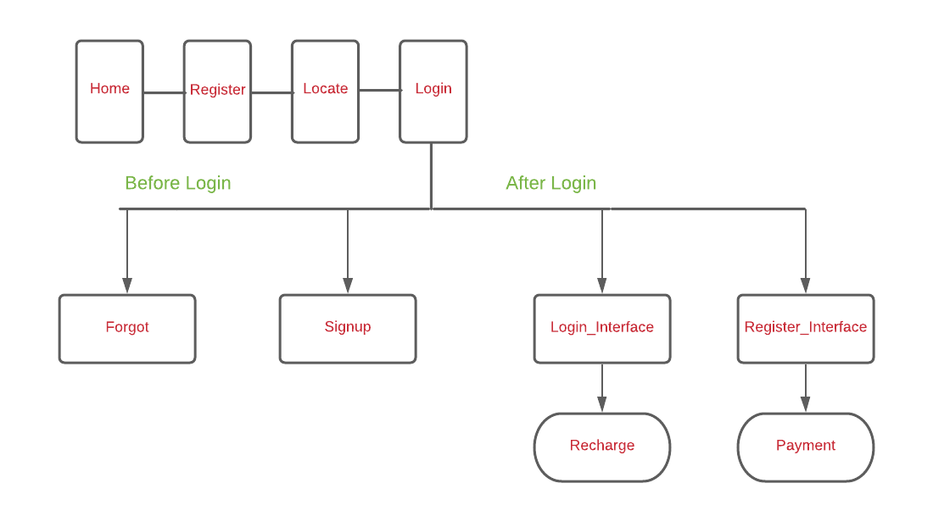

**Fig 1 system design**

**3.3 PROPOSED WORK**

In this project we are trying to build a website which will show the electric vehicle charging points nearby using maps . People can also apply for a license for charging points .Users can recharge the power card and can make payments near the charging points through the

website ,Where users can also find suggestions and queries regarding electric cars.

**4. IMPLEMENTATION AND RESULTS**

**4.1 HOME PAGE**

**LANGUAGES USED:**

1. HTML- Used to give a structure to the webpage.
2. CSS- Used to style the Structure given by html

**OVERVIEW OF HOMEPAGE:**

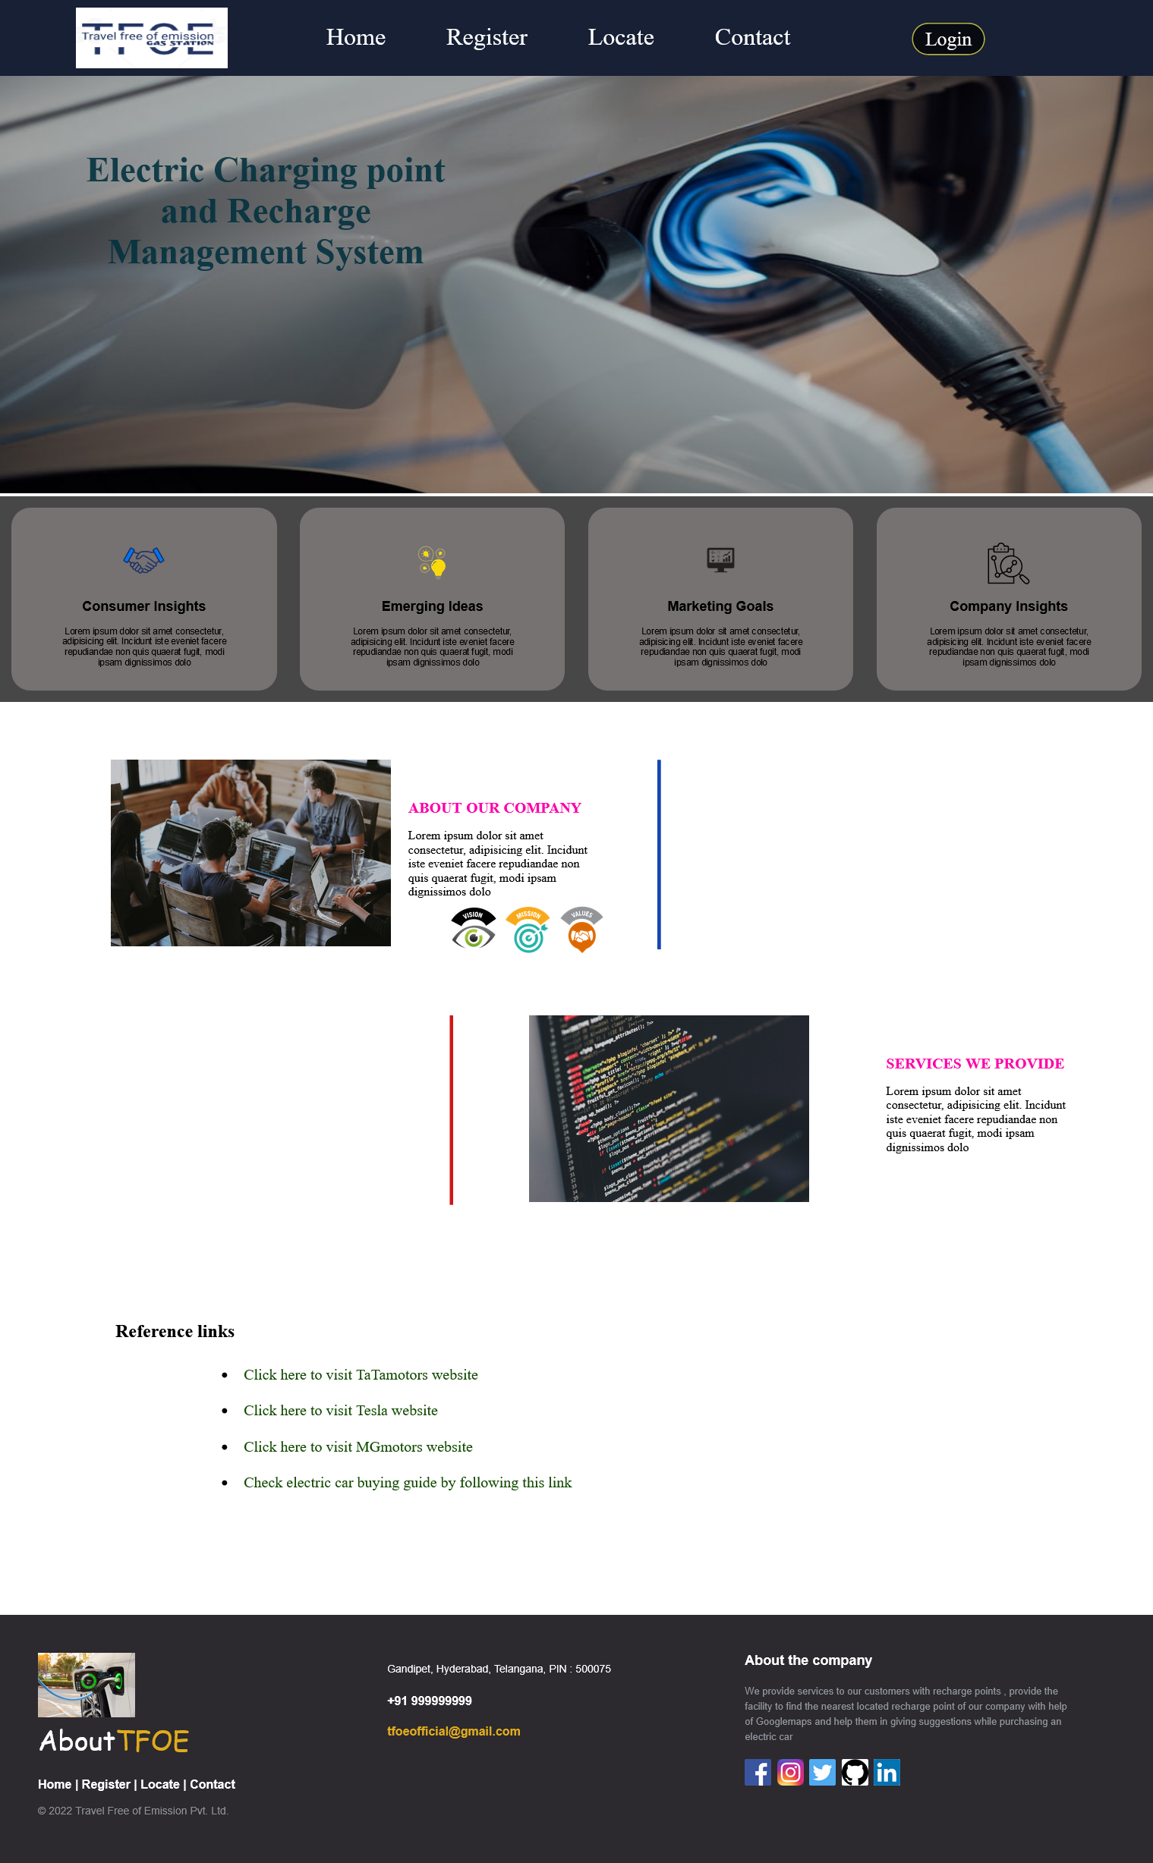

**Fig 2 Home Page 1.0**

We can see there are a couple of sections in the home page first the header section which shows us a navigation of links to other pages when we click on them we will be redirected to another pages and down we can see another section which has an image and name of our project next we can see a flex box container which is showing us the way our company works like Consumer insights , Emerging ideas , Marketing goals etc..

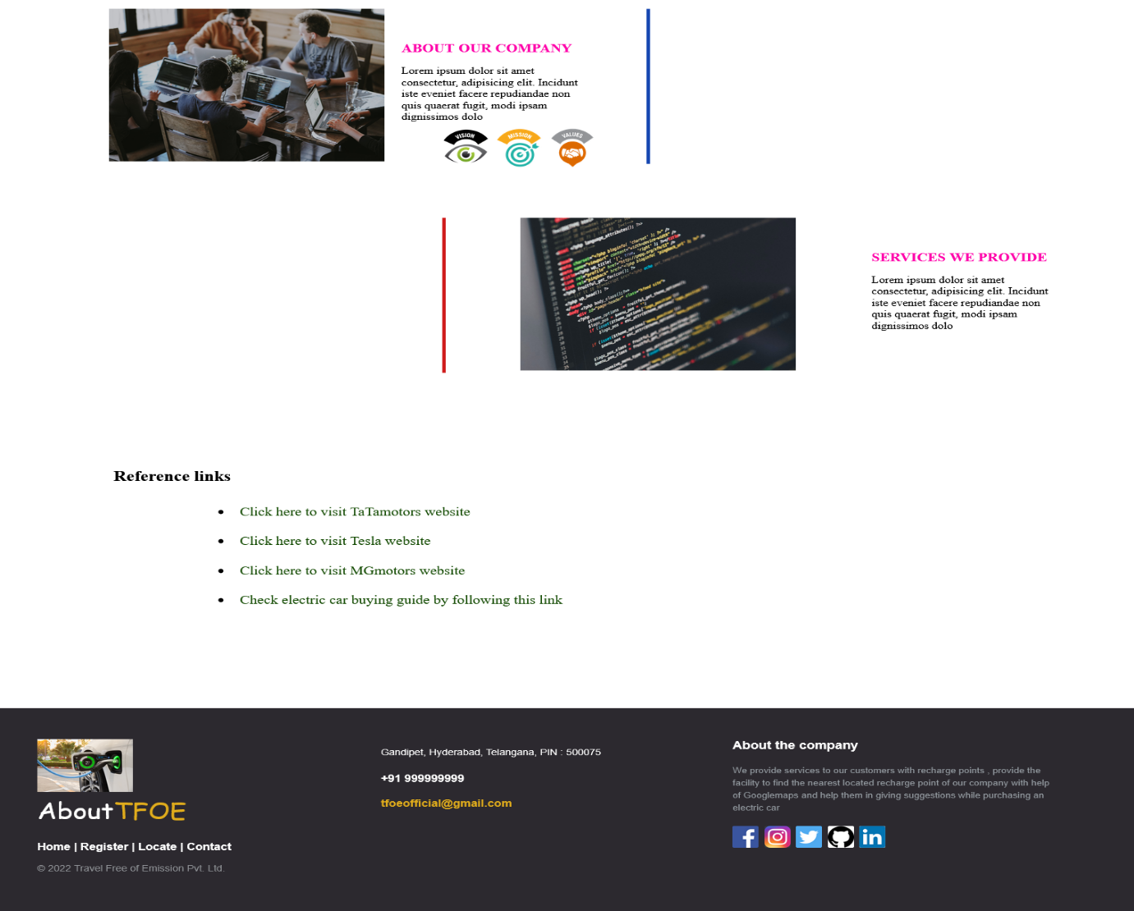

**Fig 3 Home Page 2.0**

Then we can see another section which describes our company and the services of our company followed by some reference links which are found to be helpful for the users and then the footer of the website.

**4.2 REGISTER PAGE**

**LANGUAGES USED:**

1. HTML- Used to give a structure to the webpage.
2. CSS- Used to style the Structure given by html.
3. PHP- Used to validate the inputs and store the data for login purposes.

**OVERVIEW OF REGISTER PAGE:**

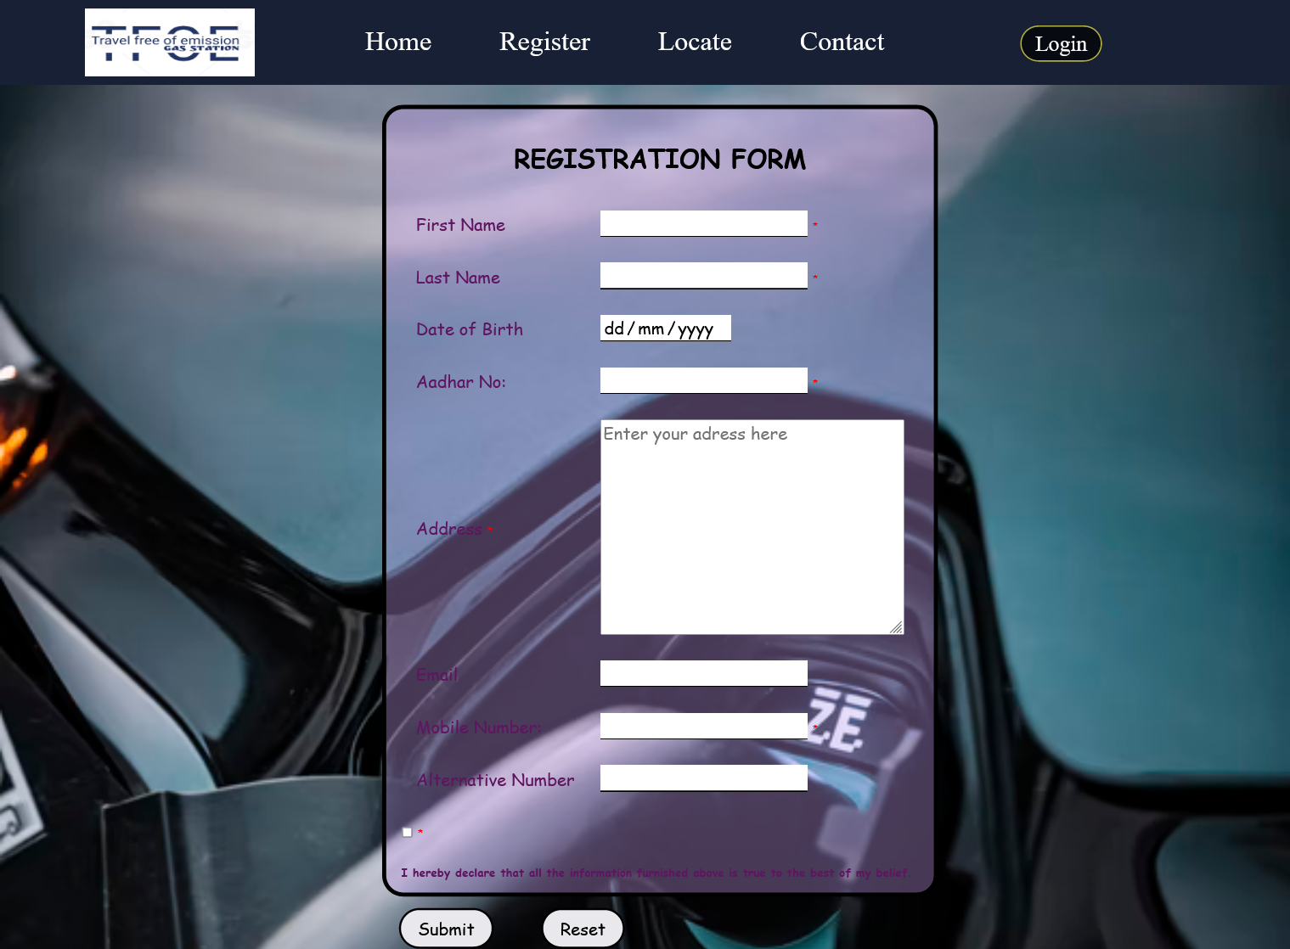

**Fig 4 Register Page**

We can see the same header sections in the main pages i.e home page , register page and locate page . After that we have the main thing that is the registration form where the registrar should enter his information asked and should check the box then click the button it submits only if the entered data is valid. After the successful submission you will the fig 1.2.2

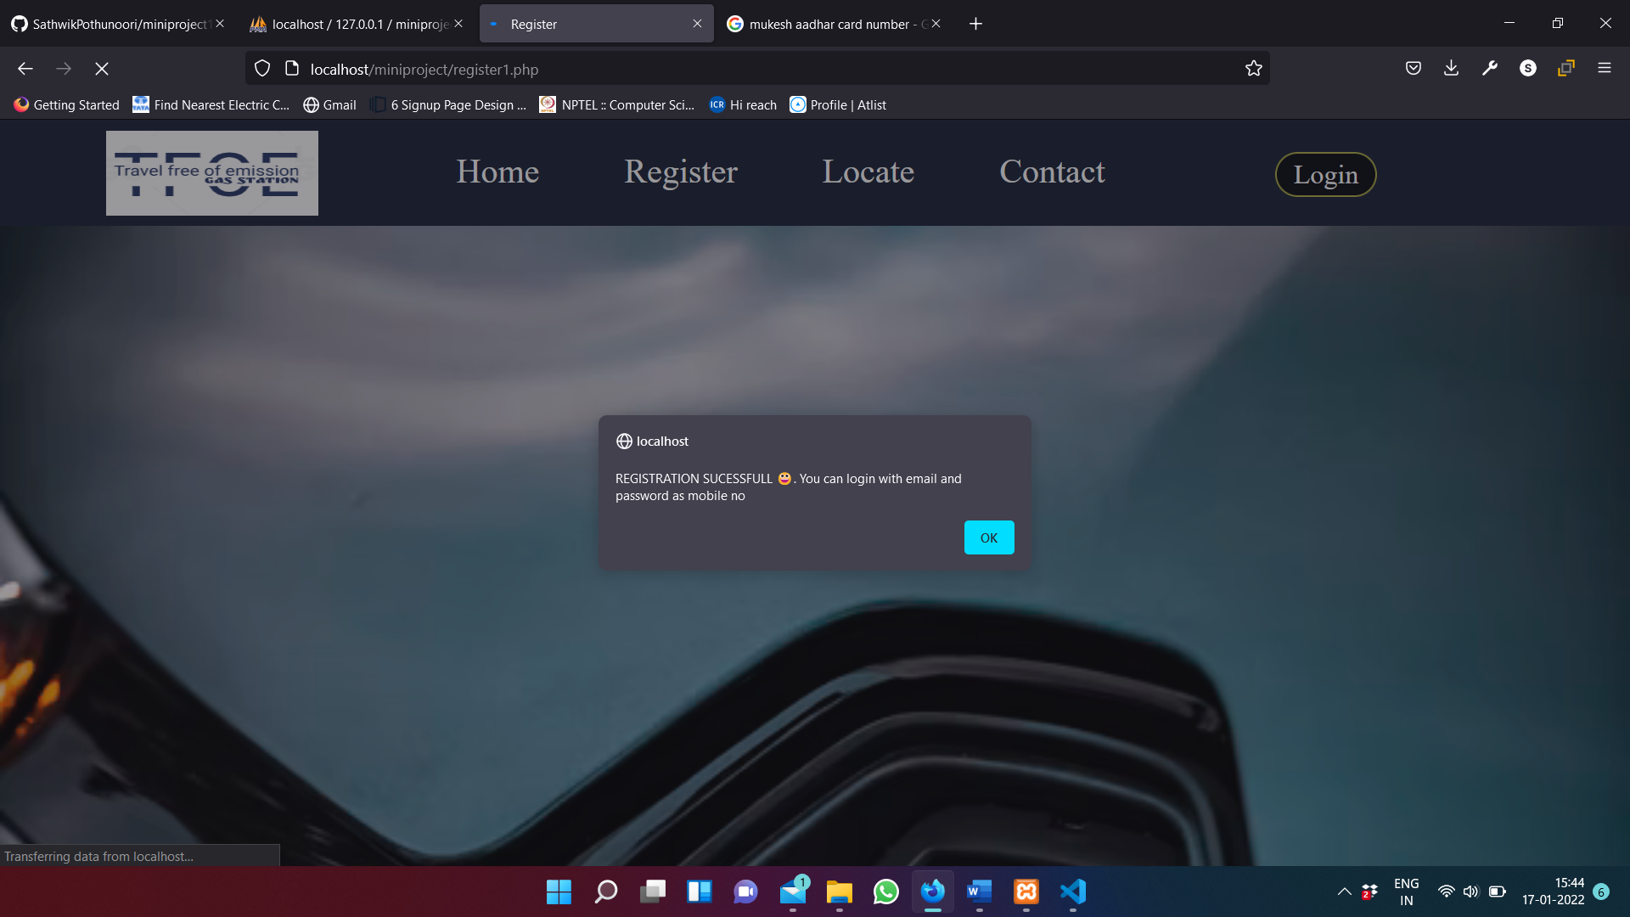

**Fig 5 Successful Registration**

After the successful signup the details will be stored in database refer below Table

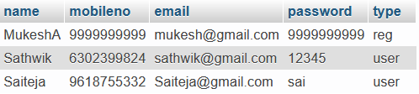

**Table 1 Successful Registration Data**

If the details entered are not valid then we will get a error message like fig 1.2.3



**Fig 6 Error Message**

Like above it comes for not only aadhar number but for all validations kept. After successful registration using email as your user name and mobile number as your password you can login.

* 1. **LOCATE PAGE**

**LANGUAGES USED:**

1. HTML- Used to adjust the map in the webpage.

**SOFTWARE USED:**

A maps service called ATLIST which can be used to mark the locations on the google maps and apply all the features of google maps on our marked locations without reflecting them in the actual google maps.

**OVERVIEW OF LOCATE PAGE:**

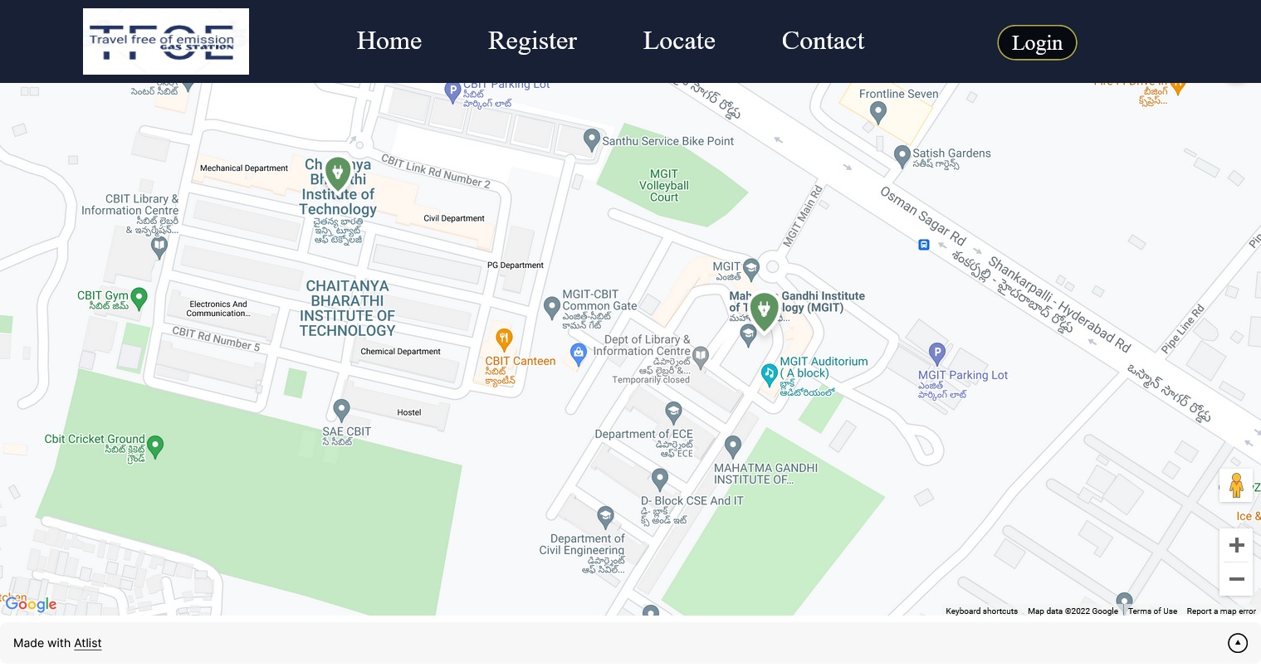

**Fig 7 Locate Page**

We can see the maps inside the locate page and we can also see some marks of an electric charging points by clicking on that we will get an option to navigate to it.You can see it in fid 1.3.2

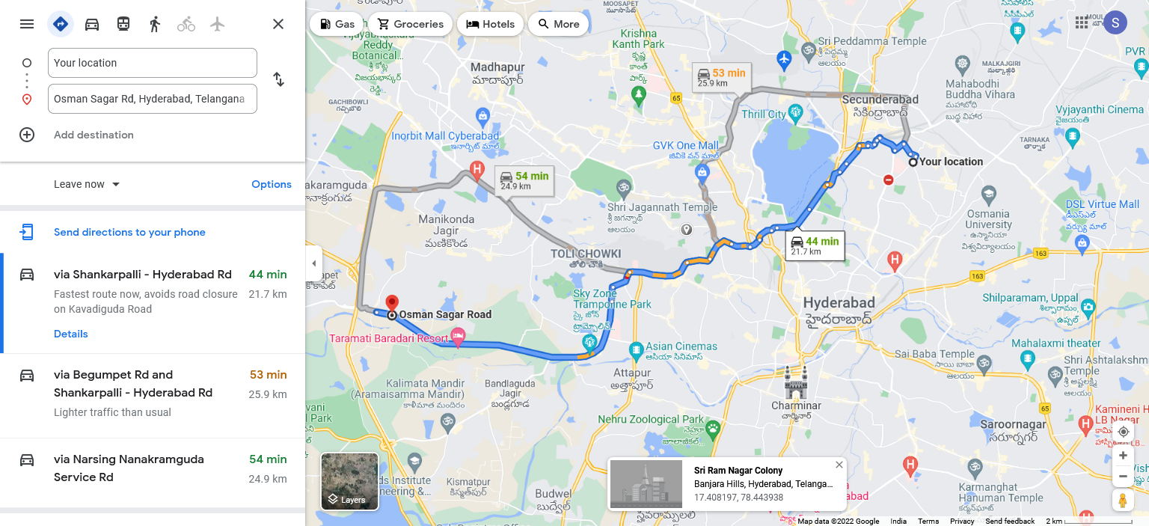

**Fig 8 Navigation**

**4.4 LOGIN PAGE**

**LANGUAGES USED:**

1.HTML- Used to give a structure to the webpage.

2.CSS- Used to style the Structure given by html.

3.PHP- Used to check if the details provided are valid.

**OVERVIEW OF LOGIN PAGE:**



**Fig 9 Login Page**

You can see 2 fields here one is his email id and other is password .If the entered details are existing then the user interface of the particular user will be opened and can make all the changes / anything the user wishes. If the logged in person is a user then the interface will look like fig 3.1.1

If the logged in person is a employee then the interface will look like fig 3.2.1

If the details are not available then it will pop out a window asking to signup. Refer to below figure

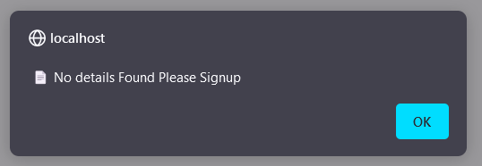

**Fig 10 Pop Up to Signup**

After clicking ok it directs to signup page

**4.5 SIGNUP PAGE**

**LANGUAGES USED:**

1.HTML- Used to give a structure to the webpage.

2.CSS- Used to style the Structure given by html.

3.PHP- Used to validate the inputs and store them for login purpose

**OVERVIEW OF SIGNUP PAGE:**



**Fig 11 Signup Page**

Here the above page can be seen when pressed the don’t have an account link on the login page (refer to fig 2.1.1 for more details) or when trying to login by entering non existing data which results in redirection to this page .

So , here we have four fields name , email , mobile no and password so on successful signup you will see the fig 2.2.2.

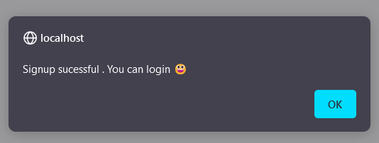

**Fig 12 Successful Signup**

The details will be stored in the database after the successful signup



**Table 2 Successful Signup Data**

If we enter the invalid data then it pops a window showing a message referring to the below figure.

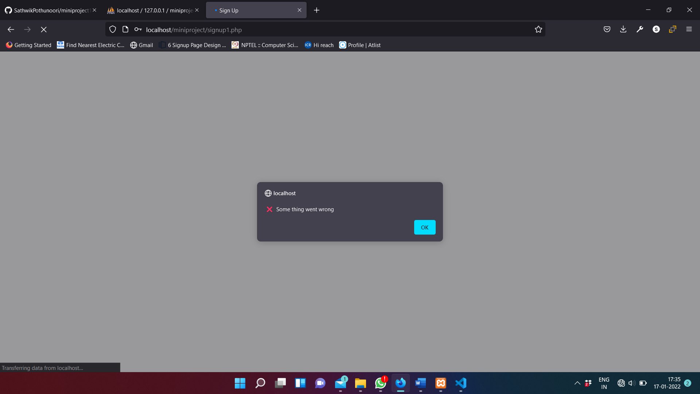

**Fig 13 UnSuccessful Signup**

**4.6 FORGOT PASSWORD**

**LANGUAGES USED:**

1.HTML- Used to give a structure to the webpage.

2.CSS- Used to style the Structure given by html.

3.PHP- Used to send an email containing a randomly generated fixed size OTP to the mail address given to the user.

**OVERVIEW OF FORGOT PASSWORD PAGE:**

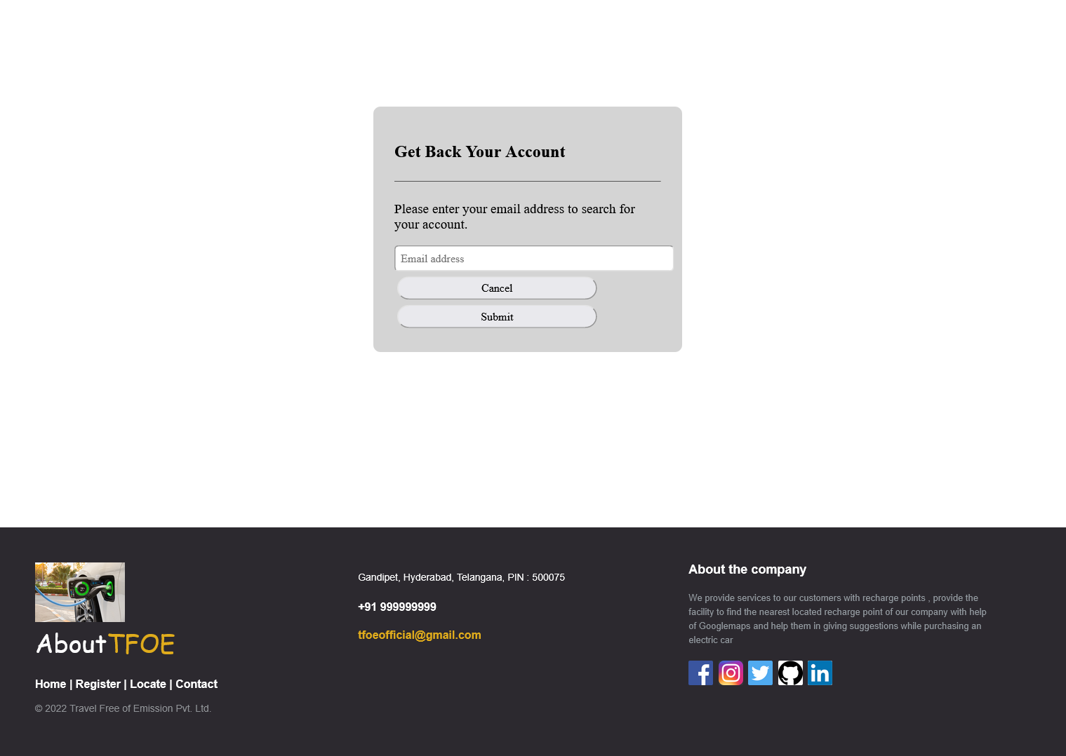

**Fig 14 Forgot Password**

Here we can see an interface which is asking us to enter the email address of the user so that an OTP will be received and after entering that OTP we can change our password and use the account.

If the entered email is not a user of the website it will show an error as below fig 2.3.2

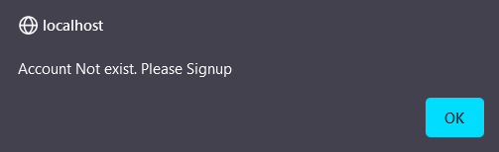

**Fig 15 Email doesn’t exist**

If we enter a valid password then we get a pop up window as shown below:

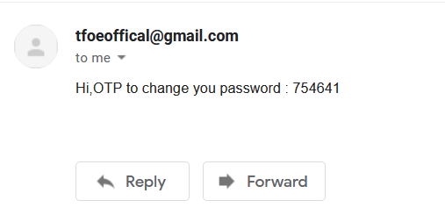

**Fig 16 Sent Mail**

* 1. **LOGIN INTERFACE**

**LANGUAGES USED:**

1.HTML- Used to give a structure to the webpage.

2.CSS- Used to style the Structure given by html.

3.PHP- Used to retrieve data from a database and display on the web.

**OVERVIEW OF LOGIN_INTERFACE PAGE:**

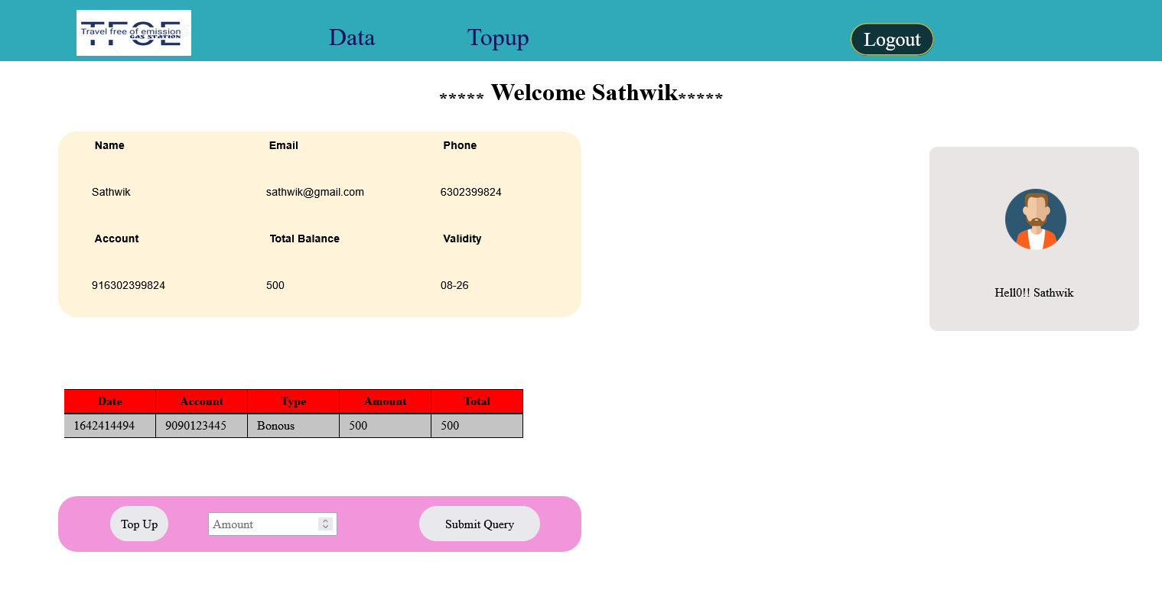

**Fig 17 Login Interface Page**

Here we can see a few sections following the header , the first one shows the preliminary data of the user like Name , Email , Phone, etc.. . The second one shows all the transactions for e.g., if the person recharges using the last section in pink with an amount of 100 then a row will be added to the table with the details of transaction and the total balance in the first section will be update by adding the amount recharged refer the figure below

First this pop up will be shown 

Then this

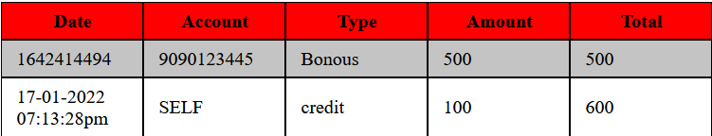

**Table 3 Successful TopUp**

**4.8 REGISTER_INTERFACE**

**LANGUAGES USED:**

1.HTML- Used to give a structure to the webpage.

2.CSS- Used to style the Structure given by html.

3.PHP- Used to retrieve data from a database and display on the web.

**OVERVIEW OF REGISTER_INTERFACE PAGE:**

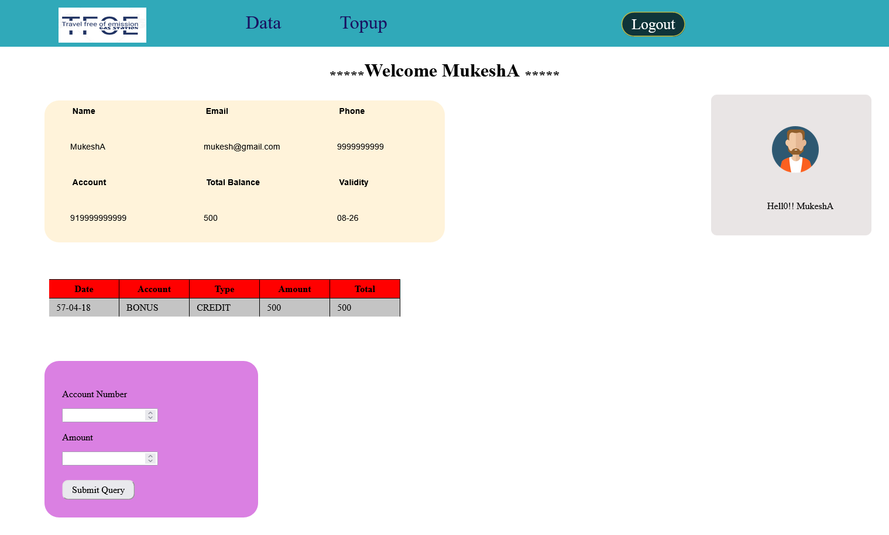

**Fig 18 Register Interface Page**

Here we can see few sections following the header , the first one shows the preliminary data of the employee like Name , Email , Phone, etc.. . The second one shows all the transactions for e.g., when the customer used the charging point at a station he has to pay to the employee so now the employee will enter the account number of the customer/user and enters the amount he need to be paid and submits .After doing such the 2nd table will be added with one row detailing the transaction and the total amount in employee account and the customer account will be affected to understand it refer below consider the amount as 50.

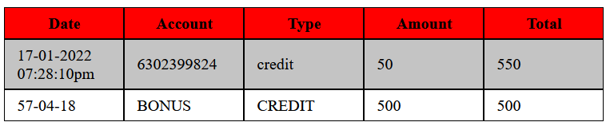

**Table 4 Successful Payment**

We can see that after the successful transaction, the amount will be deducted from the mentioned account.

After doing all these they can logout the session.

**CONCLUSION AND FUTURE SCOPE**

The project is successfully completed with all the promised services by the company.

The website is fully functioning with all the facilities provided by the company to both customers and the employee. We hope the website will be very helpful for the users and save their time and energy . We have learned a lot in the process of accomplishing this project, it’s been a good experience .

**BIBLIOGRAPHY**

1. Photo editing references: <https://www.remove.bg/>
2. Images reference: <http://unsplash.com>
3. Php reference: <http://stackoverflow.com>, <https://www.w3schools.com/php/>
4. Css reference: <http://stackoverflow.com> , <https://developer.mozilla.org/en-US/docs/Web/CSS>